**MESD LMS Documentation – Communication and collaboration through forums or messaging**

**Purpose**

To facilitate with asking and answering questions on the Q&A module, How to post topics, reply to posts and subscribe for notifications using forums, and using the messaging system.

**Background**

This module handles requests directly from Educatorswithin the Moodle system, allowing collaboration through forums and messaging.

**Usage**

**Setting up forums for Educators to use**

1. Log in as a Senior Educator or higher.
2. Select the *‘Edit mode’* toggle in the upper right.
3. Choose course where you want to add the forum and select *‘Add an activity or resource’.*

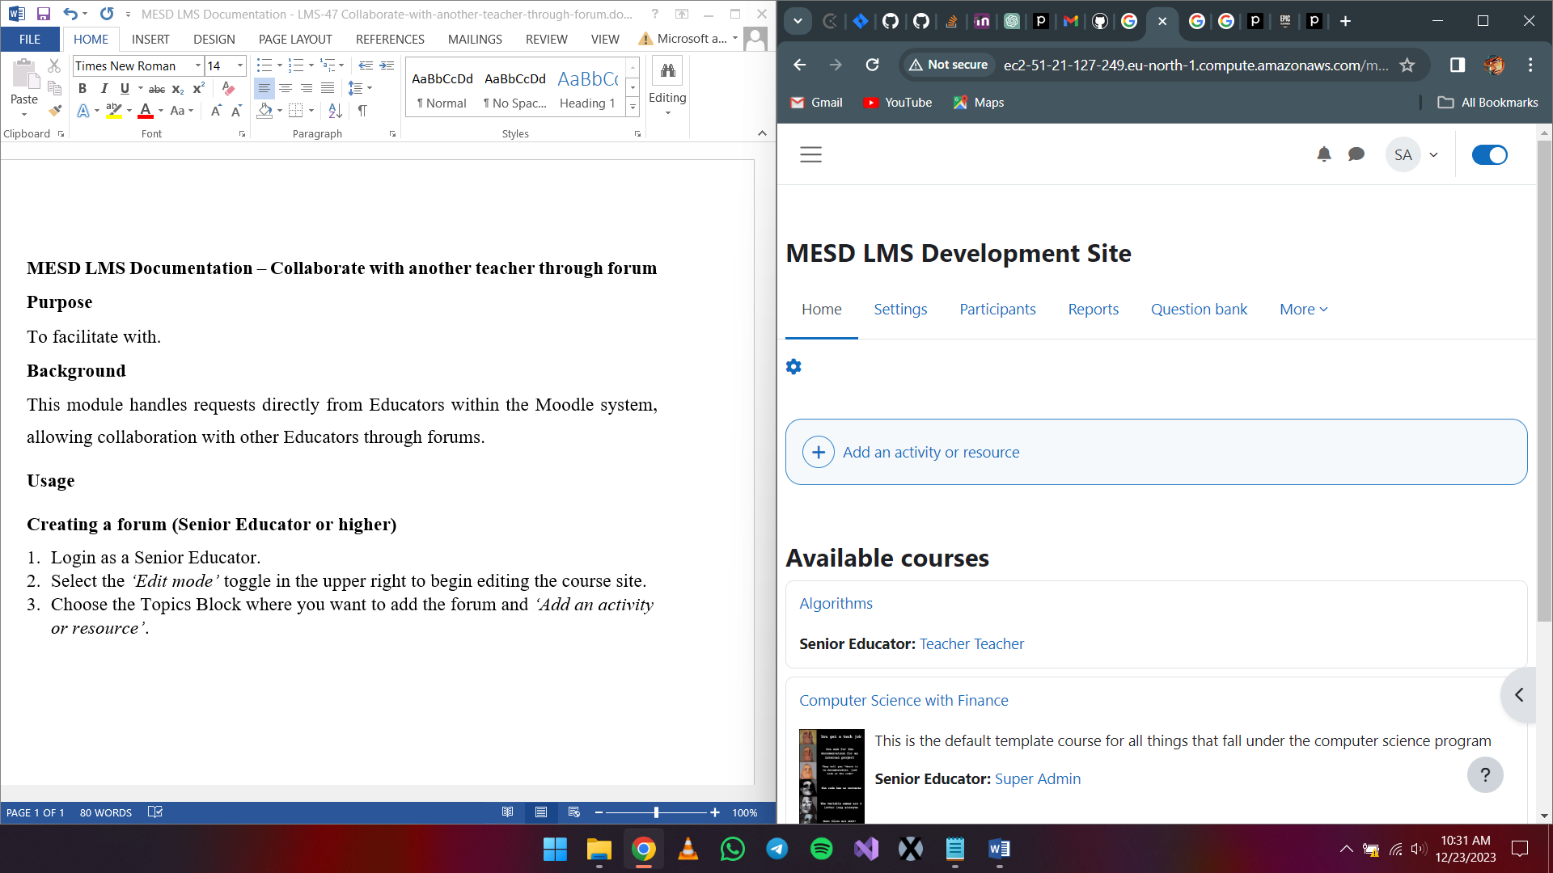



1. Choose forum.

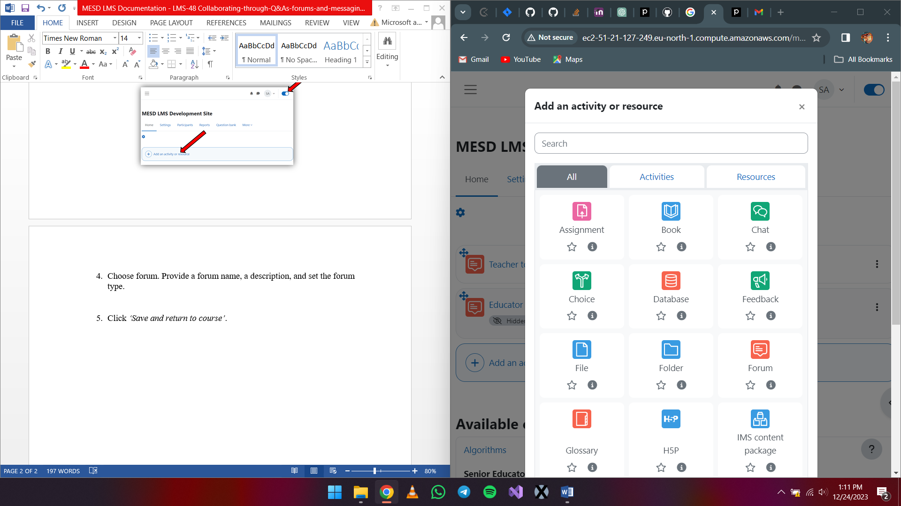

1. Provide a forum name, a description, and set the forum type.
2. Click *‘Save and return to course’*.

**Availability and assigning roles**

1. After creating the forum, while in edit mode, click the three dots to view options for that forum.

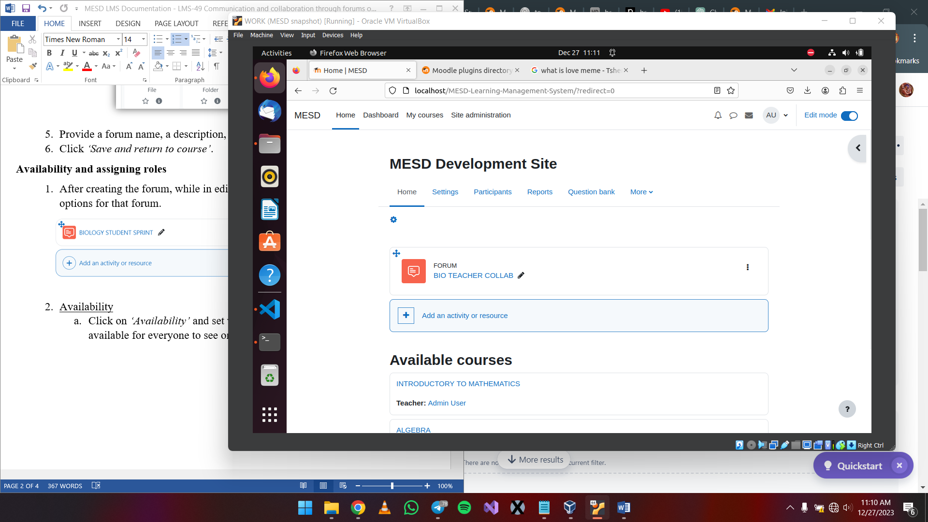

1. Availability
   1. Click on *‘Availability’* and set whether to make this forum available for everyone to see or not.

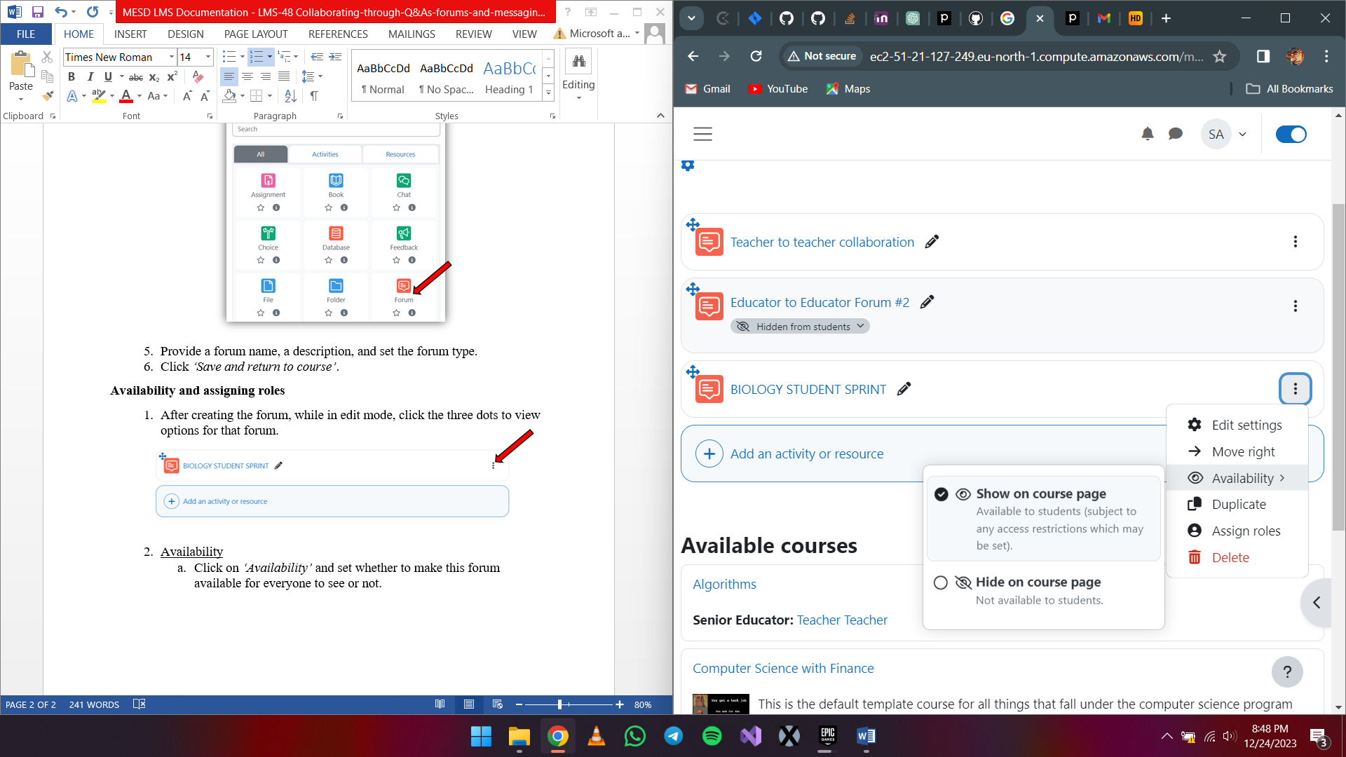

1. Assigning Roles
   1. Click on *‘Edit settings’* > *‘Subscriptions’*. Select *‘Manage subscribers’* under the View subscribers dropdown. Select the participants you want to add then click on *‘Add’*.

**Messaging**

1. Log in as an Educator
2. To send a message, click on the message icon in the navigation bar, then select the recipient you want to send the message to.

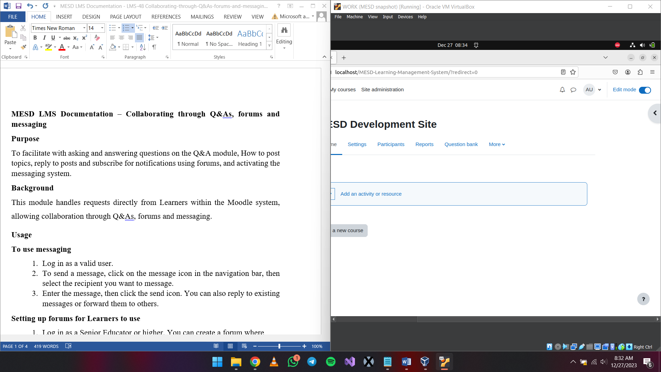

1. Enter the message, then click the send icon.

**Using the forum**

1. Login as an Educator
2. Select the forum to open it
3. Adding a discussion topic
   1. Click on *‘Add discussion topic’*.
   2. Fill in details about the subject and message. When done click *‘Post to forum’*.
4. Deleting a post in a forum
   1. Click the post you created.
   2. Click on the *‘Delete’* button.
   3. When the prompt appears select *‘Continue’*.
5. Editing a post in a forum
   1. Click on the post.
   2. Select *‘Edit’*.
6. Replying to a post in a forum
   1. Click on the post you want to reply to.
   2. Choose *‘Reply’*.